Ex.No : 11

**SELECT INTO, INSERT INTO SELECT STATEMENTS**

1.Create a new table course2 from course table

Ans)

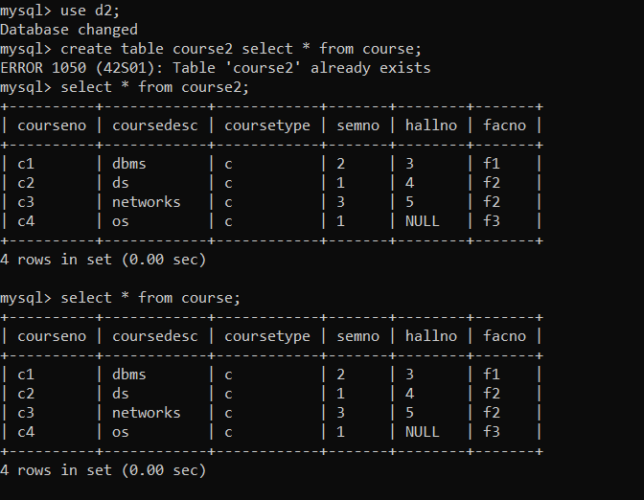

2.Insert courseno,coursedesc into course5 from course table.

Ans)

